How to Use the Gap Analysis Questionnaire

Structure

- Part 1 - Clauses 4 to 10: Covers mandatory ISO/IEC 27001:2022 requirements.
- Part 2 - Annex A Controls: Includes discretionary security controls based on risk assessments.

Answering the Questions

- Select Your Response: Use the dropdown to indicate Yes, No, Refer to comments, or Not Applicable for each question.
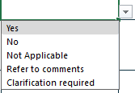

- Policy/Documentation: Provide references or citations to relevant policies or documents.

- Comments: Explain your answers for each response, mandatory for "No" or "Not Applicable."

Clarifications
- If unsure, mark the question for clarification and seek expert advice.

